|  |  |
| --- | --- |
| **Ex. No: 5** | **React based App Development** |
| **23.02.2023** |

**Aim:**

To Create an App using React with Components, Rendering, and Data Sharing.

**Algorithm:**

1. Create a new React project using a tool like Create React App.
2. Build individual components to represent various parts of your app.
3. Arrange components hierarchically, defining parent-child relationships.
4. Define the UI using JSX within components for rendering.
5. Pass data between components using props or consider state management for more complex data sharing.
6. Implement local or global state management for dynamic data and user interactions.
7. Style components using CSS, CSS modules, or CSS-in-JS libraries while keeping styling separate from logic.

**Program:**

**App.js**

import React from 'react';

import PlayerCounter from './components/PlayerCounter';

import './input.css';

function App() {

return (

<div class="bg-green-500 w-4xl ">

<div className="App max-w-2xl mx-auto justify-between items-center flex flex-col">

<div >

<h1 className='font-semibold text-4xl text-red-500 '>LET'S PLAY RUMMY</h1>

</div>

</div>

<div className="max-w-2xl mx-auto justify-between flex flex-row">

<div>

<PlayerCounter player="Player 1" />

</div>

<div>

<PlayerCounter player="Player 2" />

</div>

<div>

<PlayerCounter player="Player 3" />

</div>

</div>

</div>

);

}

export default App;

**PlayerCounter.jsx Component**import React, { useState } from 'react';

function PlayerCounter({ player }) {

const [points, setPoints] = useState(0);

const incrementPoints = () => {

setPoints(points + 10);

};

const decrementPoints = () => {

setPoints(points - 10);

};

return (

<div className="flex flex-col items-center mt-10">

<h1 className="text-xl font-semibold text-blue-500 mb-2">{player}'s Points</h1>

<div className="flex space-x-4">

<button

className="px-4 py-2 bg-blue-500 text-white rounded"

onClick={decrementPoints}

>

-

</button>

<span className="text-2xl">{points}</span>

<button

className="px-4 py-2 bg-blue-500 text-white rounded"

onClick={incrementPoints}

>

+

</button>

</div>

</div>

);

}

export default PlayerCounter

**Output:**

Github Link: https://github.com/AsHtrich/Web_tech2023

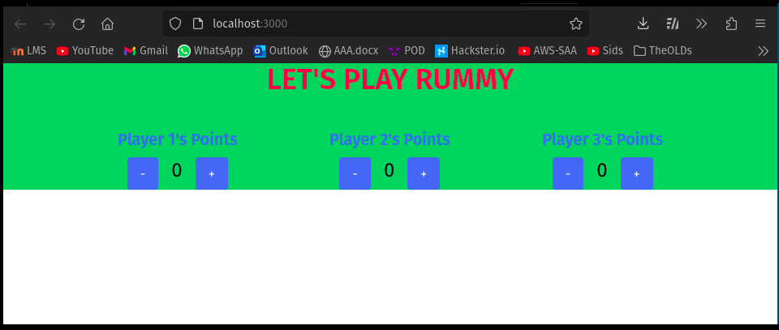

**Result:**

Therefore, we've successfully created a simple react app.